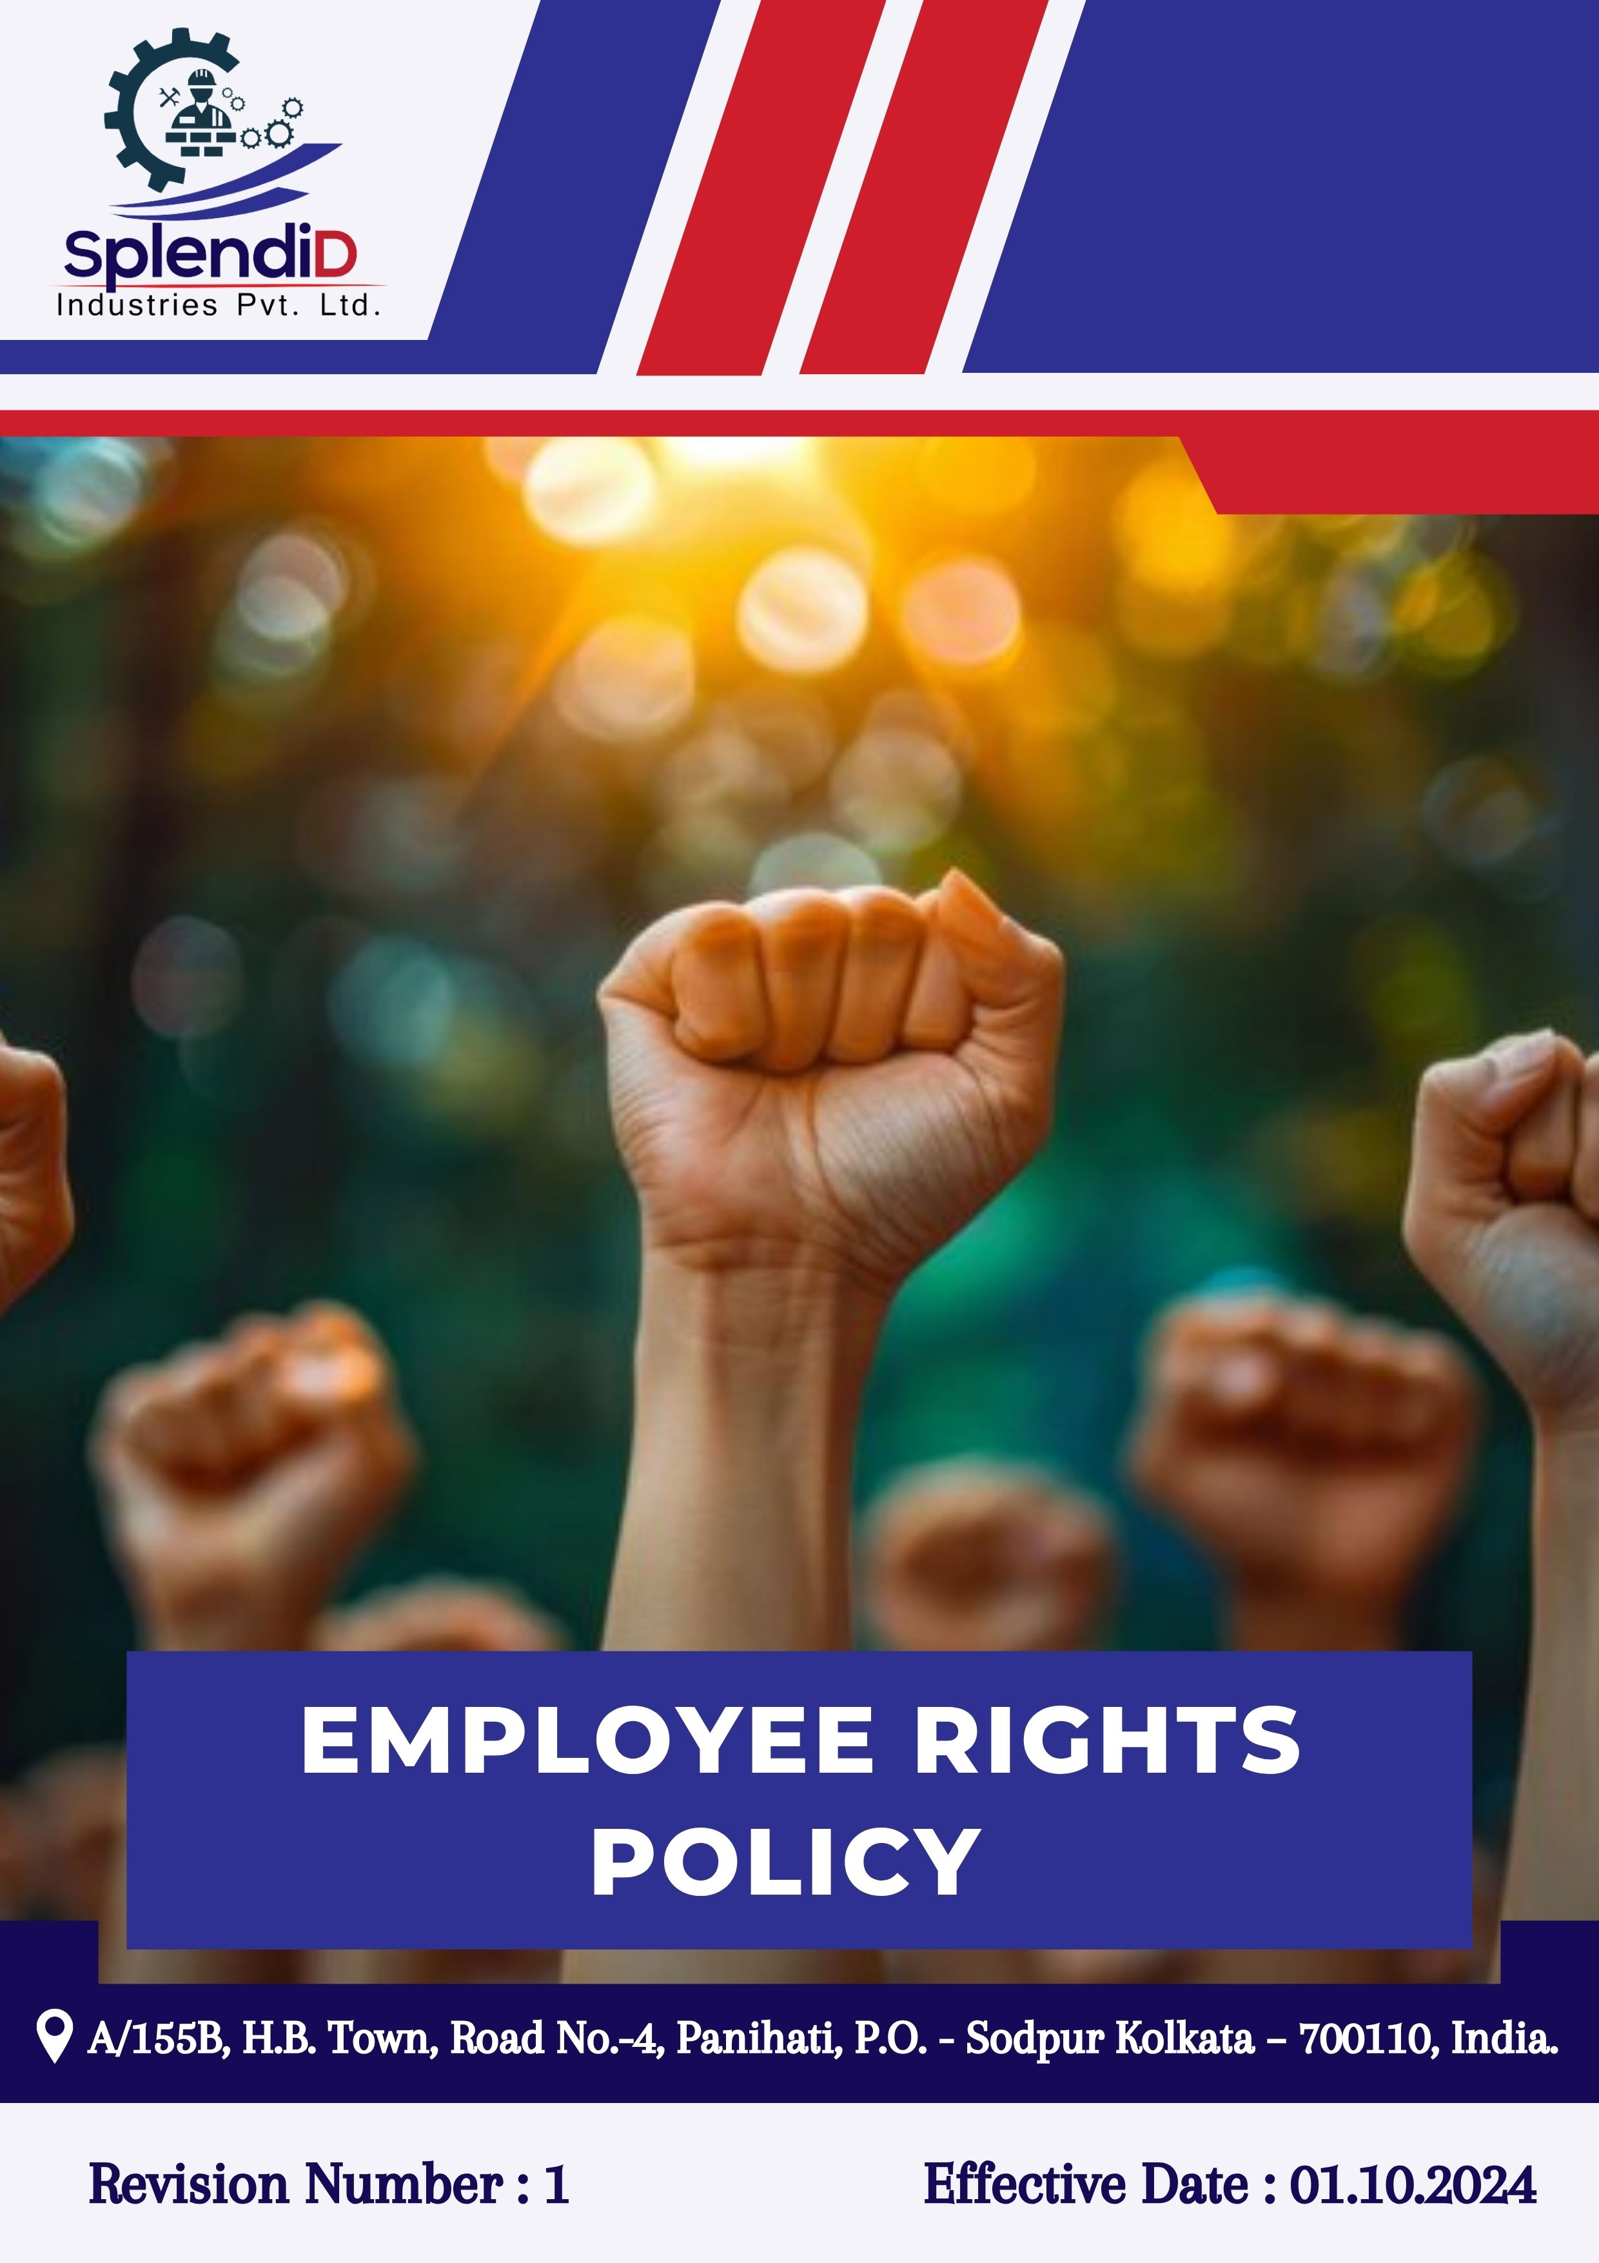

Table of Contents
Introduction 3
Scope 3
Policy Declaration 4
Key Focus Areas 4
Key Objectives and Targets 5
Targets in alignment with SDGs 8
Responsibility 8
Monitoring, Reporting & Transparency 9
Review Mechanism 9
Empolyee Acknowledgement 10

Introduction
At Splendid Industries Pvt. Ltd., we recognize that the foundation of a thriving and sustainable organization lies in the fair and dignified treatment of its workforce. This Employee Rights Policy outlines our firm commitment to protecting and promoting the fundamental rights of every employee, ensuring they are treated with respect, equity, and justice throughout their association with the company.
We are dedicated to upholding the highest standards of labor ethics and human rights across all levels of operation. This policy affirms our pledge to provide fair wages, maintain safe and healthy working conditions, and strictly prohibit all forms of forced or child labor. Every employee shall have the right to freedom of association and collective bargaining, and we are committed to creating an environment where open dialogue is encouraged and respected.
Splendid Industries Pvt. Ltd. also ensures that all employees have access to transparent and effective grievance mechanisms without any fear of retaliation or discrimination. We aim to establish a workplace culture rooted in mutual trust, inclusivity, and continuous improvement, where employee rights are not only protected but actively promoted.

Scope
This Policy is applicable to following sites and all of its employees, workers, sub-contractors and other stakeholders.
Sr. No. | Site | Address
1 | SPLENDID INDUSTRIES PVT.LTD. | A/155B, H.B. Town, Road No.-4, Panihati, P.O. - Sodpur Kolkata – 700110, India.

Policy Declaration
At Splendid Industries Pvt. Ltd., employees are recognized as the foundation of our success, and we are committed to ensuring their fair and respectful treatment at all times. This policy ensures that all employees are aware of their rights and are protected against any form of discrimination, exploitation, or unfair treatment in the workplace. We align all labor practices with applicable laws and ethical standards, and promote fair wages, safe working conditions, equal opportunities, and the prohibition of forced or child labor. The company respects the right to collective bargaining and guarantees access to grievance mechanisms without fear of retaliation. These principles apply to all employees, and it is the responsibility of every manager to uphold and implement them consistently.

Key Focus Areas
- Occupational Health and Safety – Maintain safe workplaces by managing physical risks and preventing work-related injuries or illnesses.
- Mental Health and Well-being – Support emotional well-being through awareness, stress management, and access to confidential support.
- Fair and Safe Working Conditions – Ensure lawful wages, working hours, and respectful treatment in a clean and secure environment.
- Employee Engagement and Social Dialogue – Promote open communication, uphold collective bargaining rights, and involve employees in workplace decisions.
- Training, Development, and Career Growth – Provide learning opportunities and performance feedback to foster skill development and advancement.
- Elimination of Child and Forced Labor – Prohibit child labor, forced labor, and trafficking across operations and supply chains, with strict enforcement.
- Non-Discrimination and Anti-Harassment – Ensure equal opportunity and a workplace free from bias, discrimination, or harassment of any kind.
- Respect for Stakeholder Human Rights – Protect the rights of communities, partners, and suppliers by conducting due diligence and ethical business practices.
- Workforce Diversity and Inclusion – Foster a diverse, inclusive workplace that values different backgrounds, experiences, and perspectives.

Key Objectives and Targets
All targets outlined in the Employee Rights Policy are based on the baseline data from FY 2022–23. Progress will be evaluated annually, with the objective of achieving key milestones by FY 2029–30, covering key areas such as employee well-being, ethical labor practices, inclusivity, fair compensation, and responsible partnerships.
- Occupational Health and Safety
- Regularly enhance health and safety protocols to proactively address workplace risks and promote employee well-being and hence maintain zero absenteeism due to work-related injuries.
- Ensure 100% accessibility to health and safety information and emergency protocols for all employees.
- To increase safety inspections by 5% till FY 2029-30 to proactively identify risks.

- Mental Health and Well-being
- Promote psychological safety by raising awareness, offering stress management tools, and ensuring confidential mental health support is accessible to all.
- Organize 2 mental health awareness campaigns per year.

- Fair and Safe Working Conditions
- Promote a workplace culture that prioritizes ethical practices, psychological safety, and employee satisfaction.
- Conduct employee satisfaction surveys annually on working conditions, aiming for 95% positive responses by FY 2029-30.
- Ensure implementation of a formal channel for 100% employees to discuss working conditions with management by FY 2029-30.

- Employee Engagement and Social Dialogue
- Foster open dialogue through structured communication channels and inclusive participation in workplace decision-making.
- Ensure 100% of employees have access to formal platforms to express concerns and feedback.
- To conduct annual labor-management meetings with documented minutes and action points.
- Achieve 70% response rate in employee engagement activities by FY 2029–30.

- Training, Development, and Career Growth
- Promote continuous learning through structured training, career planning, and periodic performance reviews.
- Conduct annual performance reviews and ensure career development plans are in place for 100% of eligible employees.
- Allocate 20% of the financial budget to employee development programs by FY 2029-30.
- Increase internal promotions by 10% by FY 2029-30 by implementing structured career pathways and targeted upskilling programs.

- Elimination of Child and Forced Labor
- Enforce and maintain zero tolerance for child, bonded, or forced labor across all operations and suppliers.
- Conduct background checks for 100% of new suppliers before onboarding regularly.
- Train 100% procurement and recruitment staff on labor compliance policies annually.
- Maintain zero confirmed cases of child or forced labor.
- Non-Discrimination and Anti-Harassment
- Ensure an inclusive, respectful workplace free of bias, discrimination, and harassment and hence maintain zero cases of harassment or discrimination.
- Provide 100% of employees with annual anti-harassment and non-discrimination training.
- Conduct workplace climate surveys on discrimination and harassment till FY 2029-30 through survey forms filled by 100% employees.
- Respect for Stakeholder Human Rights
- Integrate human rights due diligence into business operations and key relationships to mitigate rights-related risks.
- Conduct human rights risk assessments annually.
- Ensure that 100% of supplier contracts include and comply with human rights clauses by the FY 2029-30.
- Train 100% of procurement teams on human rights policies annually.
- Maintain zero reported human rights violations across operations.
- Workforce Diversity and Inclusion
- Build an inclusive culture that encourages diverse perspectives and equal opportunity.
- Increase female workforce participation by 10% by FY 2029–30.
- Apply inclusive hiring guidelines in 100% of recruitment processes.
- Conduct annual diversity and inclusion training for all employees.

Targets in alignment with SDGs
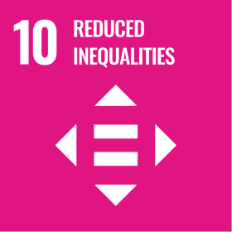

Responsibility
The following teams and individuals are jointly responsible for upholding and implementing the Employee Rights Policy at Splendid Industries Pvt. Ltd.:
- Management – Promote a respectful workplace and provide necessary support.
- HR Department – Communicate the policy, manage employee records, and address grievances.
- Supervisors– Ensure fair practices and support employee well-being.
- Employees – Respect others' rights, follow the policy, and report violations.

Monitoring, Reporting & Transparency
The company is committed to upholding employee rights through regular monitoring, transparent reporting, and responsive action. Confidential channels are provided for employees to report issues such as discrimination, harassment, or unsafe conditions without fear of retaliation. All valid complaints are addressed fairly and within defined timeframes. Key Performance Indicators (KPIs) are maintained to track complaint resolution rates, training coverage, and policy effectiveness. Annual summaries and performance data are shared to promote transparency, with findings used to strengthen policies, training, and workplace practices.

Review Mechanism
The Employee Rights Policy of Splendid Industries Pvt. Ltd. will be reviewed annually by the HR Manager to ensure it remains effective, legally compliant, and aligned with best practices and stakeholder expectations. The review will evaluate the adequacy of current commitments, address implementation gaps, and consider feedback from employees, compliance teams, and external stakeholders. Significant changes in labor laws, human rights norms, or internal assessments may prompt an earlier review. All updates will be approved by senior management and clearly communicated across the organization to uphold transparency and accountability.
Effective Date: 01.10.2024
Next Review Date: 01.10.2025
Approved By:

Empolyee Acknowledgement
I hereby acknowledge that I have read and understood the Employee Rights Policy of Splendid Industries Pvt. Ltd. I am aware of the company’s strong commitment to upholding fair labor practices, fostering a safe, respectful, and inclusive work environment, and safeguarding the rights and well-being of all employees.
I understand that every employee is entitled to fair treatment, equal opportunity, freedom of association, just and timely compensation, and safe working conditions. I recognize that these rights are essential to a positive and ethical workplace and that maintaining such an environment is a shared responsibility.
By signing this document, I commit to respecting the rights of all colleagues, reporting any violations or concerns through the designated grievance channels, and actively participating in training and awareness initiatives related to employee rights and workplace ethics. I affirm my support for Splendid Industries’ dedication to a transparent, equitable, and rights-focused organizational culture.

Employee Name  Employee ID  Date  Signature | :_______________________________  :_______________________________ :________________________________  : _______________________________

